LAB ASSIGNMENT – 2.2

AI Assisted coding

Task -1: Description

* : Use Gemini in colab to write a function that filter out all negative numbers from a given list
* Prompt: Generate the python code without using functions that filters out all negative numbers from the users input.

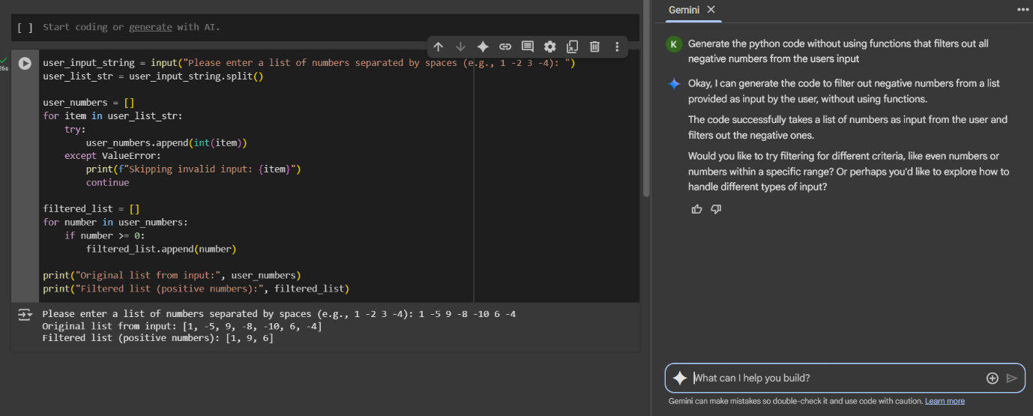

* Observation: Gemini can understand the task very clearly.It take very less time to complete the task and the output is accurate and matches the example provided.

Task-2:

* Description: Ask Gemini to generate code that reads a text file and counts the frequency of each word. Then ask it to explain the code.
* Prompt: Generate a python code that reads a text file and print the count of frequency of each word.
* 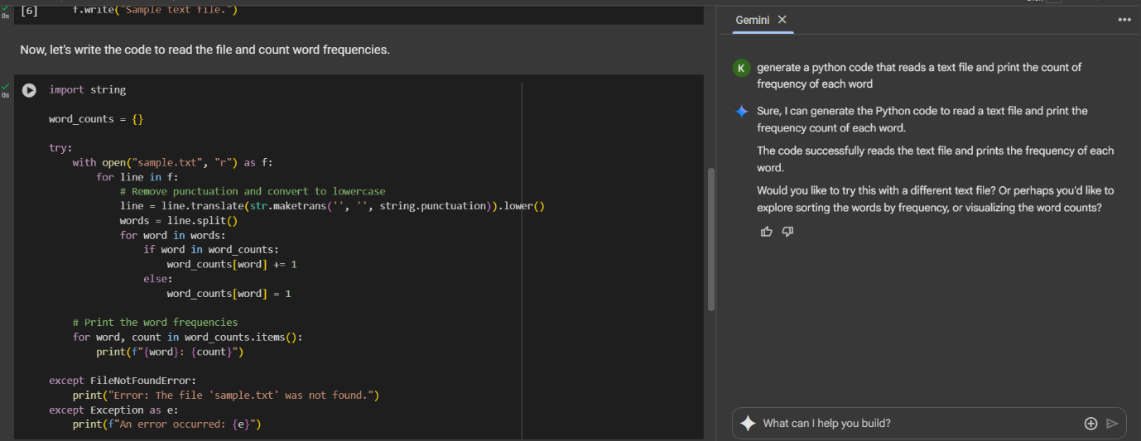
* 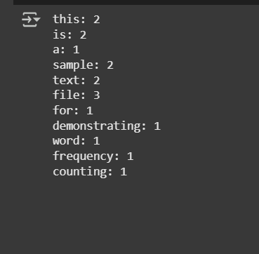
* Explanation of code:
* 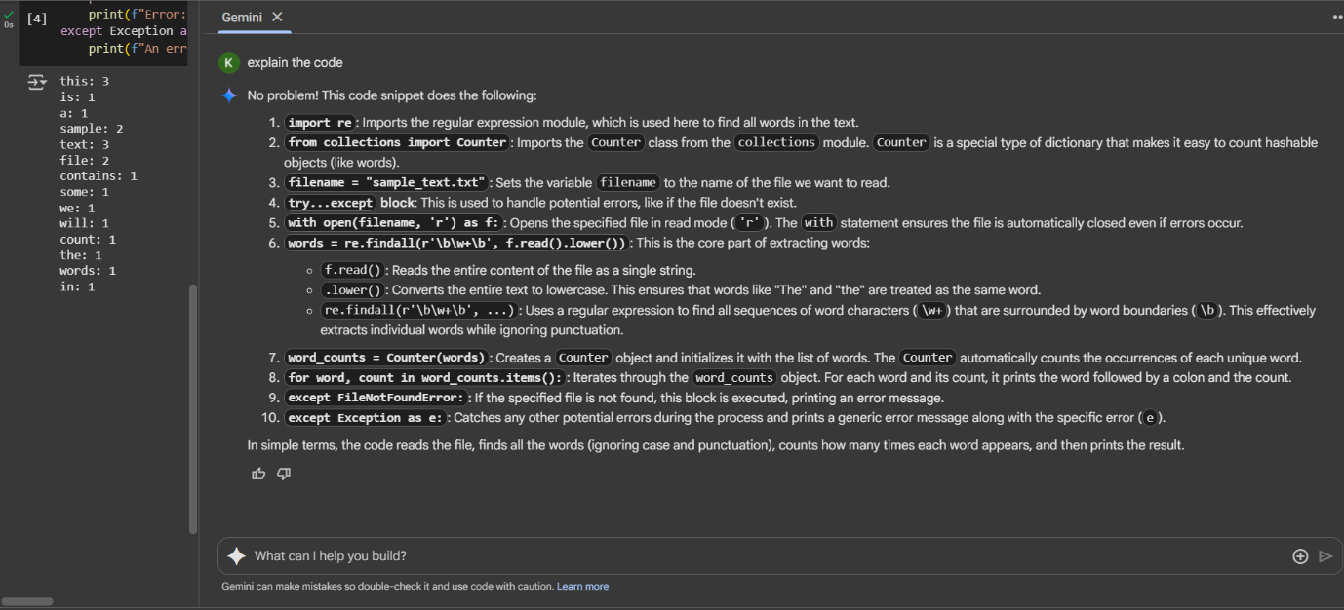

Task3:

* Description: Use cursor AI to generate a python class called Book with attributes, title, author, and a method summary() that prints the details.
* Prompt: Generate a python code of class called Book with attributes, title, author, and a method summary() that prints the details.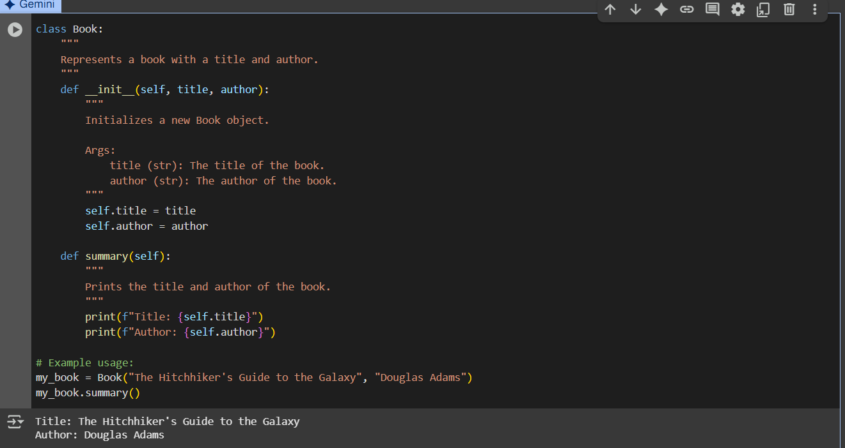
* Observation: Cursor AI correctly uses the class keyword to define the book class, following python object-oriented programming conventions. The _init_() method is implemented. The code assigns self.title and self.author properly.

Task4:

* Description: Ask the gemini to write a program that checks whether a number is an Armstrong number, and then modify it using Cursor AI to improve performance or structure.
* Prompt: Generate the python code to check whether a number is Armstrong number.

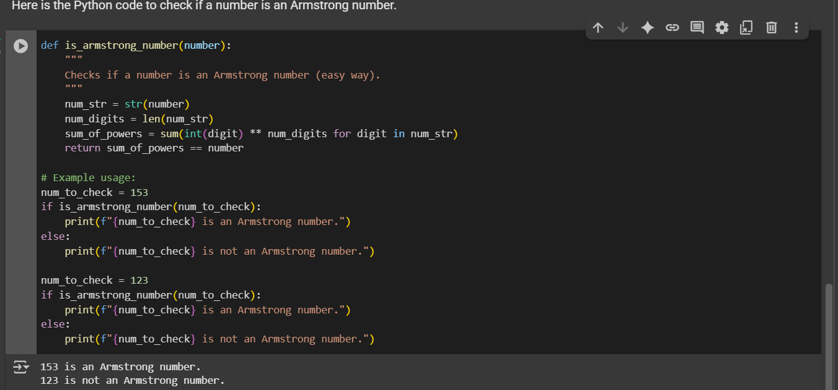

* Observation: Gemini included sample input like 153 or 9474 and show that code correctly identifies them as Armstrong numbers. Raising each digit to the power of the number of digit.

Task5:

* Description: Use the both Gemini and Cursor AI to generate code for sorting a list of dictionaries by a specific key (e.g., age).
* Prompt: Generate a python code for sorting a list of dictionaries by a specific key
* Gemini Code:

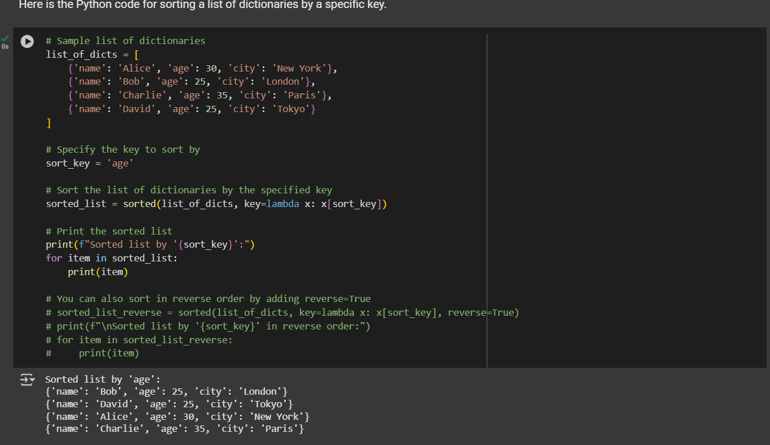

* Cursor Code:

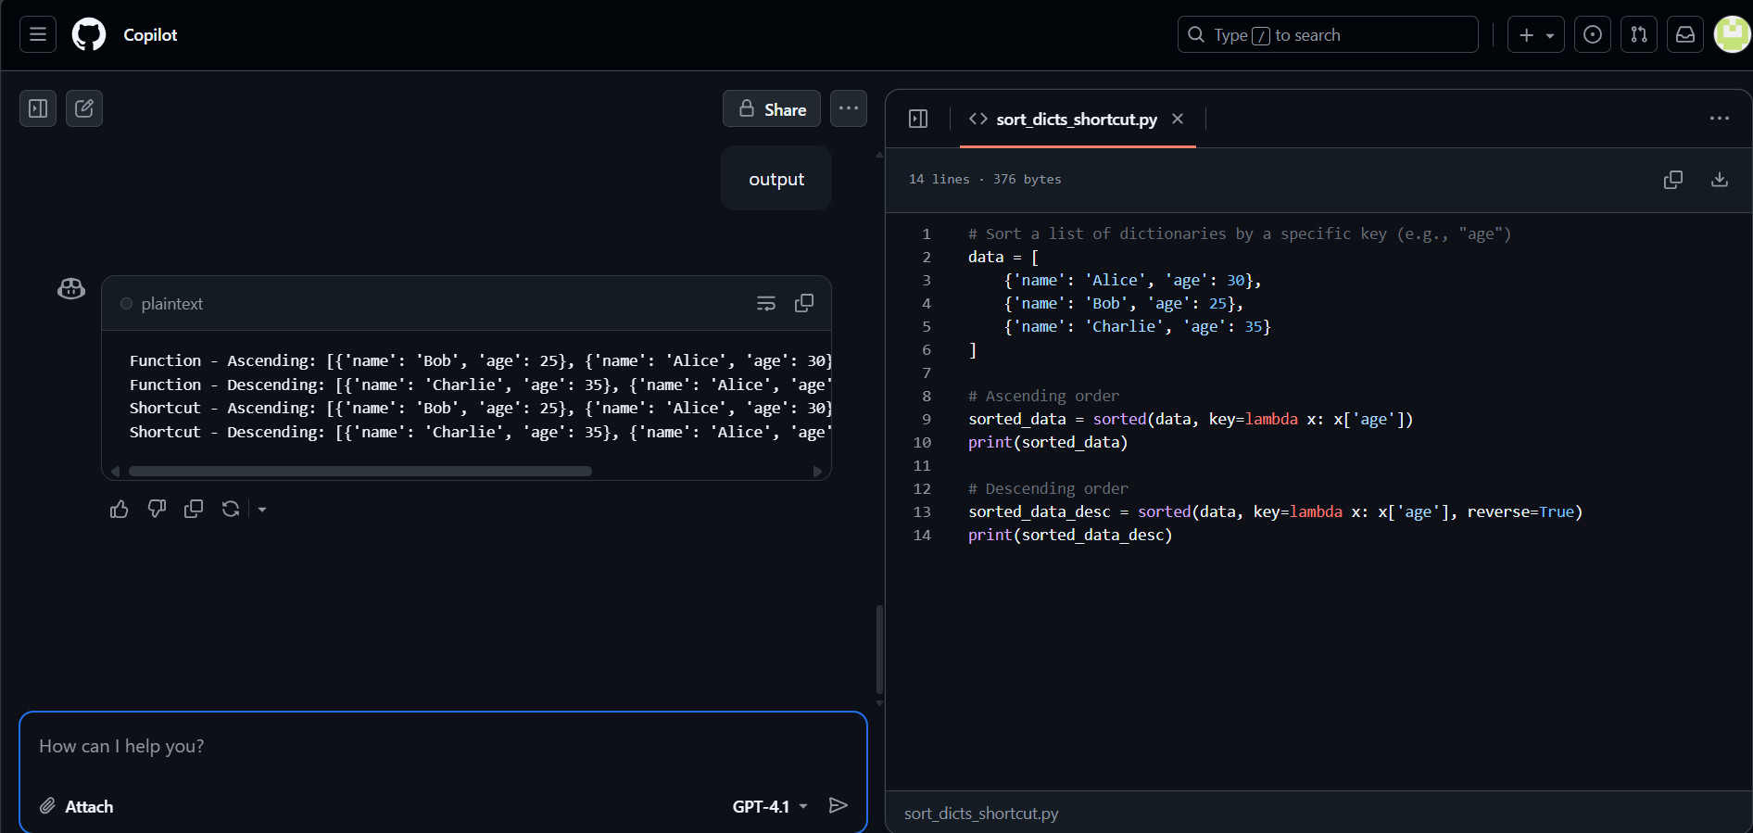

* Observation: Gemini typically uses python bulit-in sorted() function with a key argument like lambda x:x[‘age’] , which is the standard and efficient way to sort.

Copilot sorts a list of dictionaries by the key "age".In ascending order: youngest to oldest.In descending order: oldest to youngest.Uses sorted() with a lambda to pick the "age" value.